Chakraborty, Veekram (Cognizant)   
Dutta, Shilpi (Cognizant)

Duck creek training document

**Claims Application Overview**

**Claims Dashboard:**

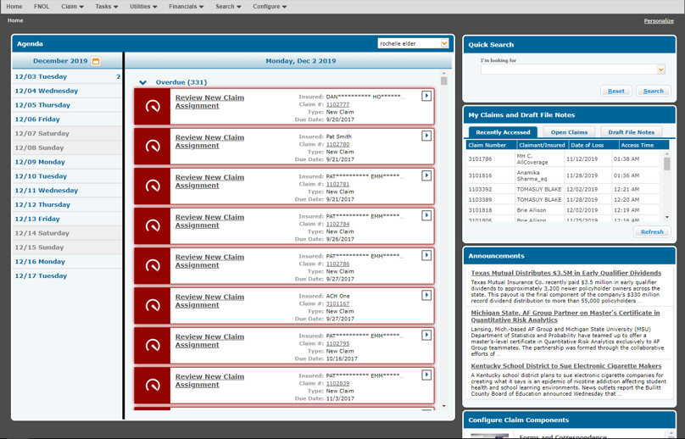

**Starting FNOL:** Click on FNOL from menu to start the FNOL transaction:

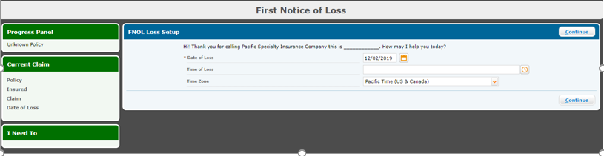

**Note:** The Date Of Loss should be >= Policy Effective Date. We can only claim once the policy is issued.

**Policy Search:** Enter the policy no on which user wants to claim and click on Search

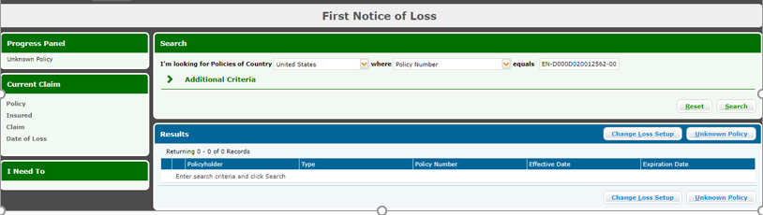

Once the policy is searched it will displayed in the grid.

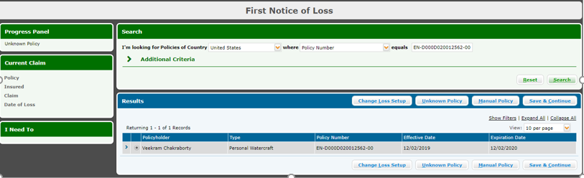

**Policy Attachment to Claims:** Click on Save and Continue to attach the policy:

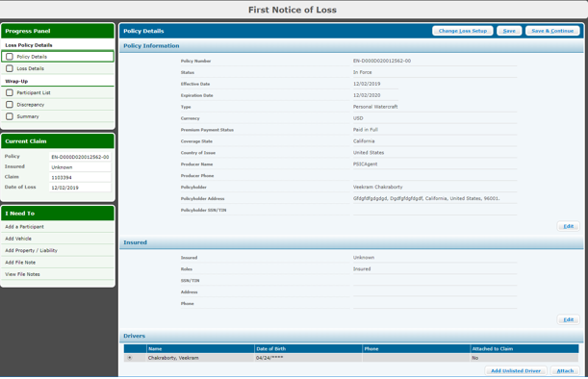

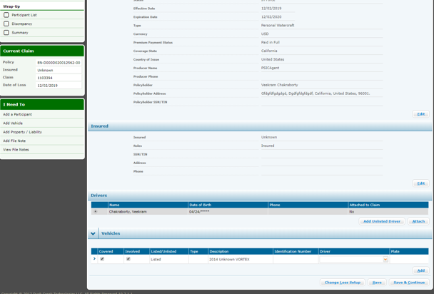

**Claims Group adding:**

Once the policy is attached all the policy details should be displayed properly. This policy details will flown from Policy to Claims.

Click on Save and Continue:

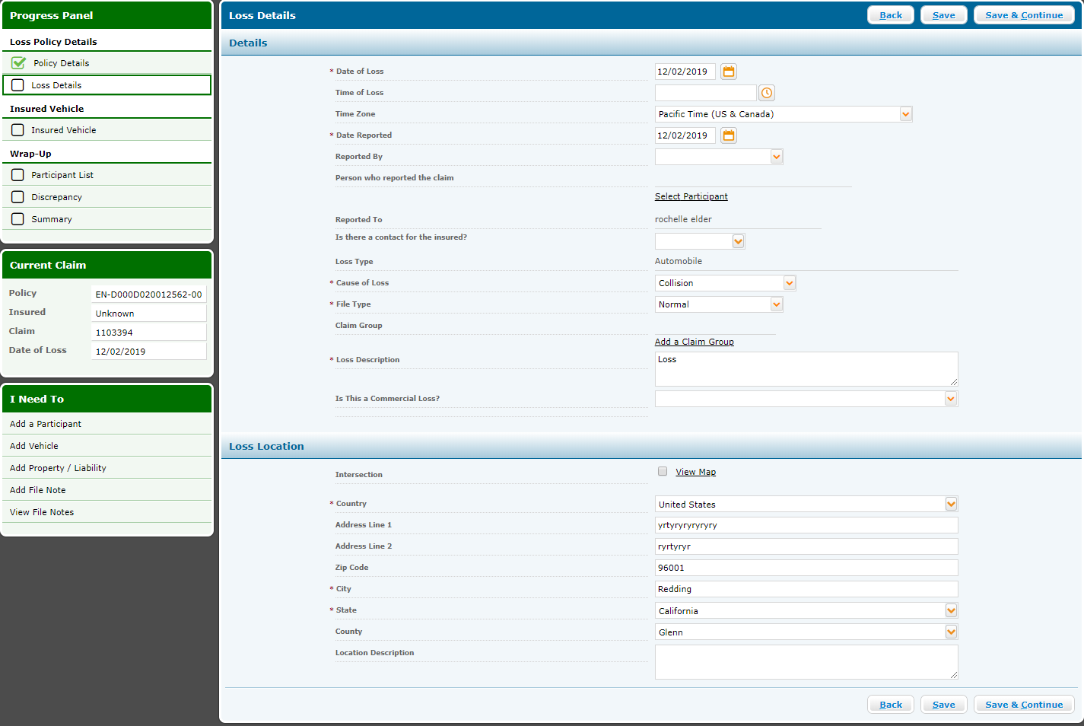

**Note:**

* Based on the Cause Of Loss and Claims complexity the claims gets assigned to particular group.
* A Claim group is a group of people in the organization (Insurer Company) who is responsible to analyzing the claims and take decision. Different Claims groups has different rights and responsibility and specialization to analyze different types of claims w.r.t Cause Of Loss and Claims complexity.
* User has provision to assign the Claims to a particular group manually by clicking on Add a Claim Group

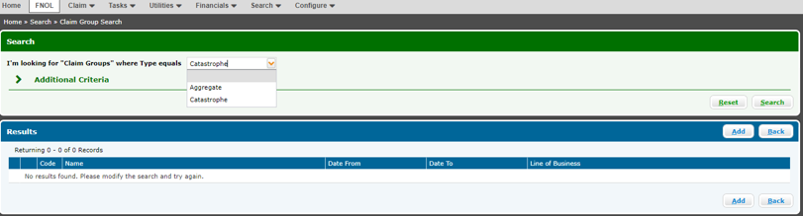

**Note:**

* Claims group segregations depending on insure requirements. Different insurer can have different claims group
* Here we have Catastrophe and Aggregate

Select any group and click on search and the users from the particular group will be displayed.

Select the user from the claims group and click on continue.

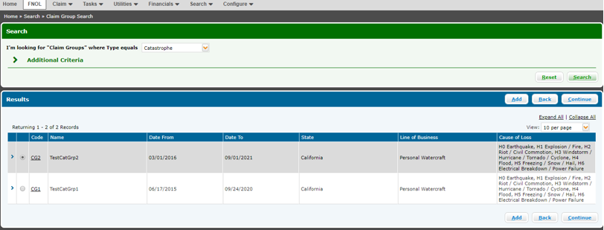

Once we click on the pop up confirmation message to add claim group the claims group will be added successfully and will be displayed on Loss Details page.

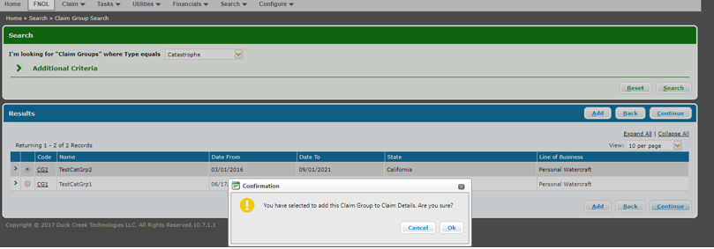

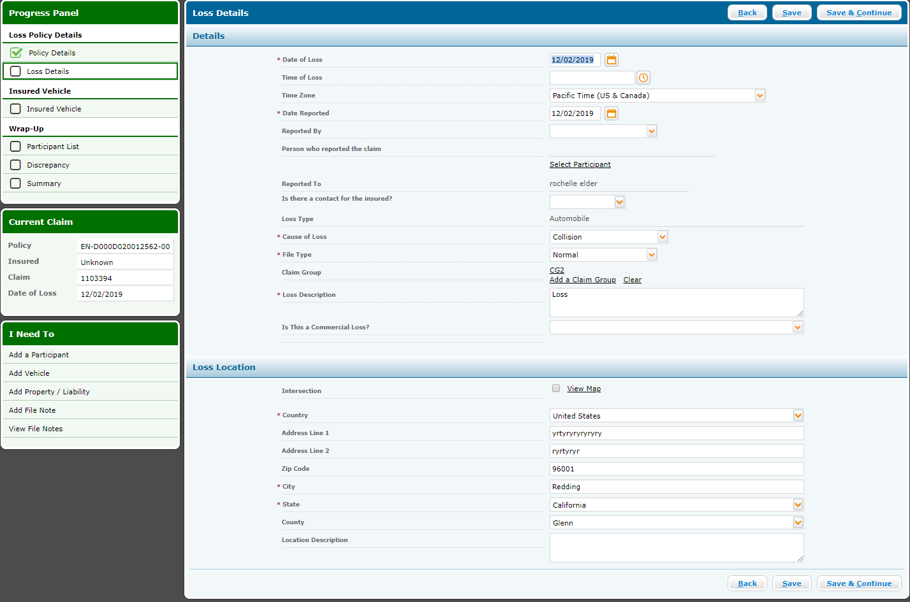

Click on Continue and Key facts page will be displayed.

Key facts page will list down the answers of some questions related to the claim (Ex: Type of accident, Location of accident any witness etc). Fill all the required inputs and click on continue.

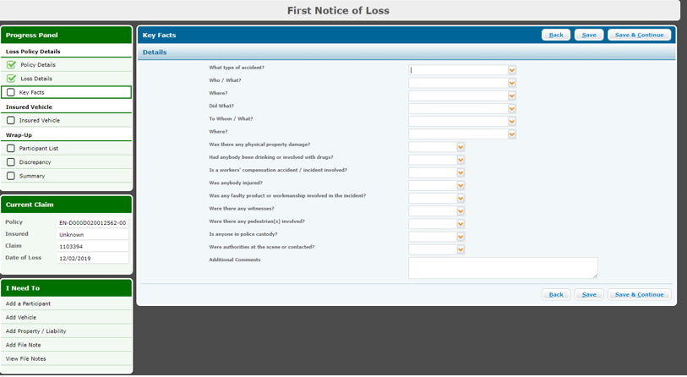

**Additional Driver Adding:**

The driver page will allow the user to add driver details during claims creation. This is when the vehicle is being driven by someone who has not being listed during policy creation.

Please note this is client specific implementation. In general user can only claim based on the details entered during policy creation.

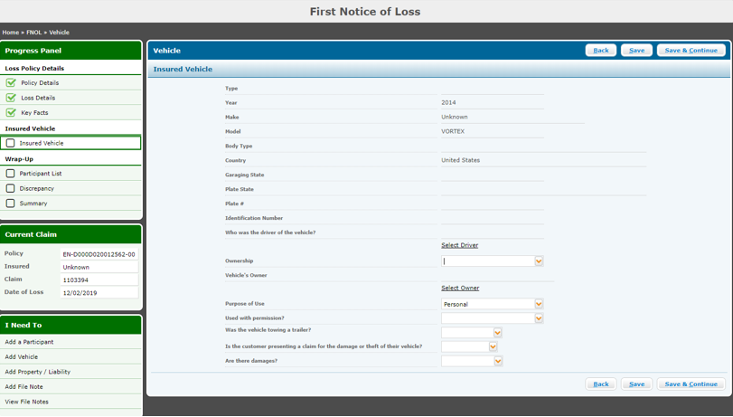

* Participant List will display all the participants associated with the claims.
* In order to make payment for the claim one participant with claimant has to be present on the claim
* If no claimant is already added to the claims we need to add claimant by clicking on Add Participants button.

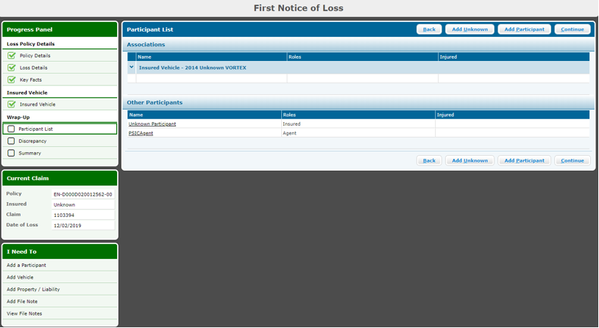

**Claimant Adding:**

* On Party search pop up search a party.
* The party should be added to claims system during system configuration as per client requirement. If you do not know the party details reach out to system configuration team/Client BA.
* Once the party is searched select the party and click on select

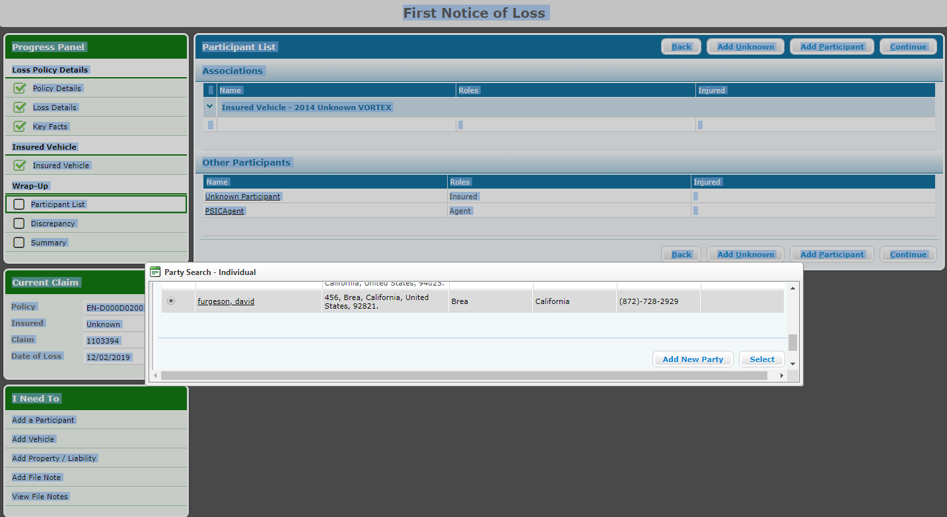

On Participant Details screen fill the below fields.

* Roles as Claimant
* Where there any violation: we have to mention the violation type here.
* Participant association: This is to mention the party association. Means whom the part is associated with (Whether part is associated with Insurer, participants- Insured or it is an unknown party)

Click on Same and Close.

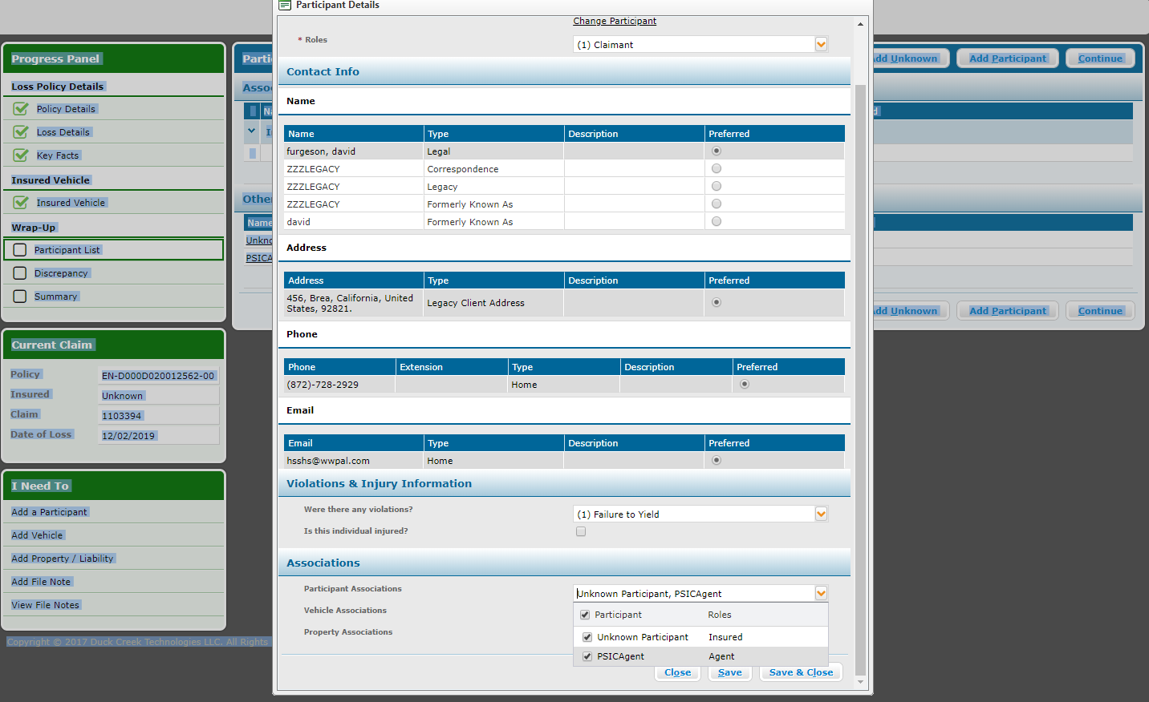

Once the part is added it will be displayed on Participant List screen. Click on continue.

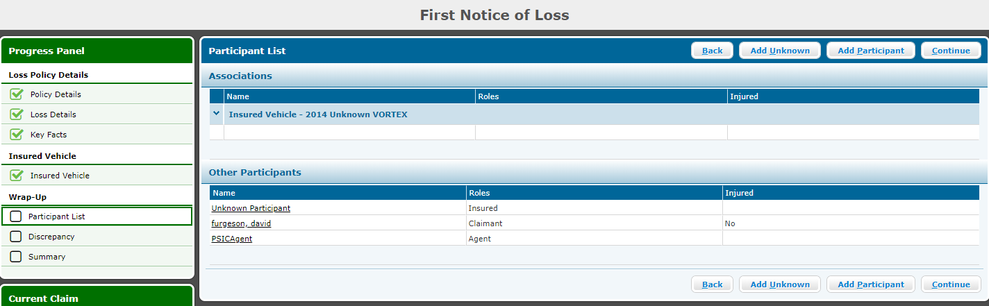

The discrepancy screen will list down all discrepancies in the claims and that needs to be corrected before completing the FNOL.

The Resolution Required filed will display whether the discrepancy is mandatory to be corrected or not.

* If Resolution Required filed is Yes then those discrepancies need to be corrected before FNOL completion.
* If Resolution Required filed is No then we can complete the FNOL without correcting those discrepancies

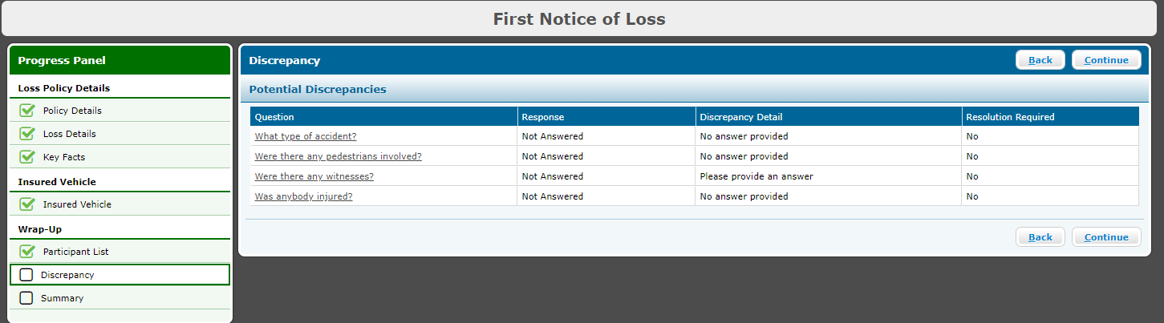

**FNOL Complete:**

The summery screen will display all the claim details. After validating all the details click on FNOL Complete. This will complete the FNOL process and will hit the Duck Creek Claims system for Claim no Generation.

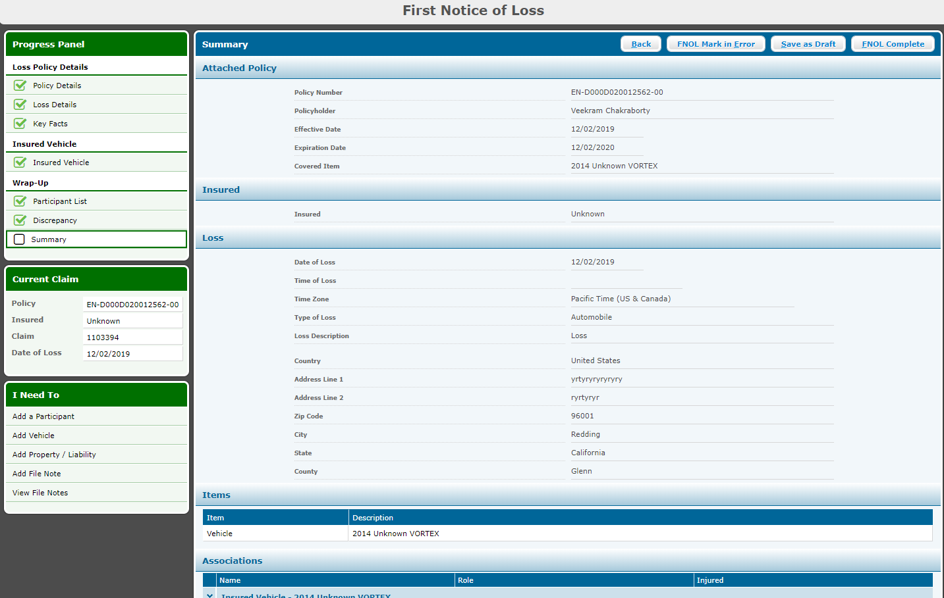

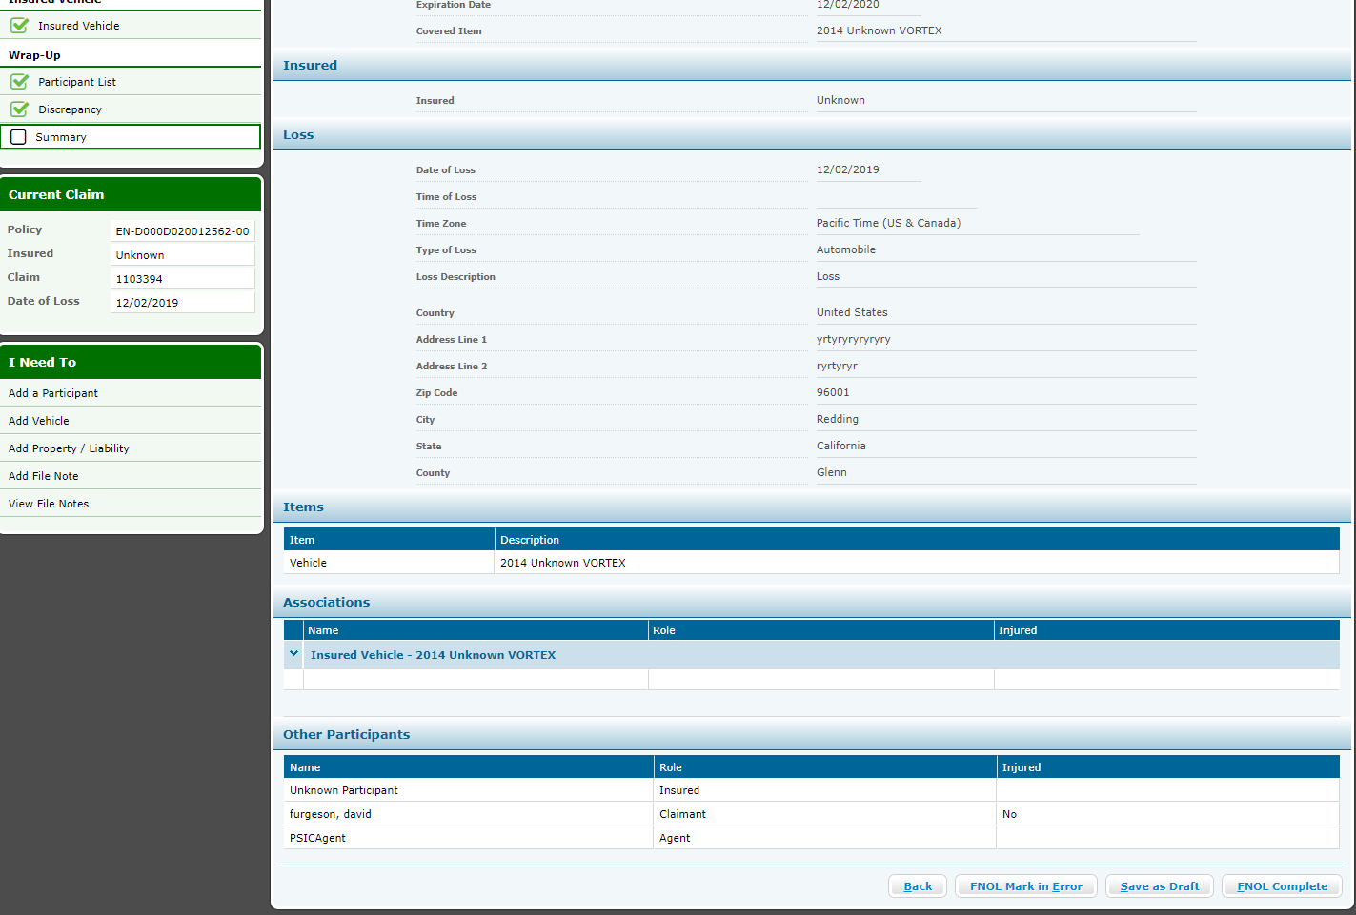

**Claim Number Generation:**

Click on The Claim no generated and system will open the claim.

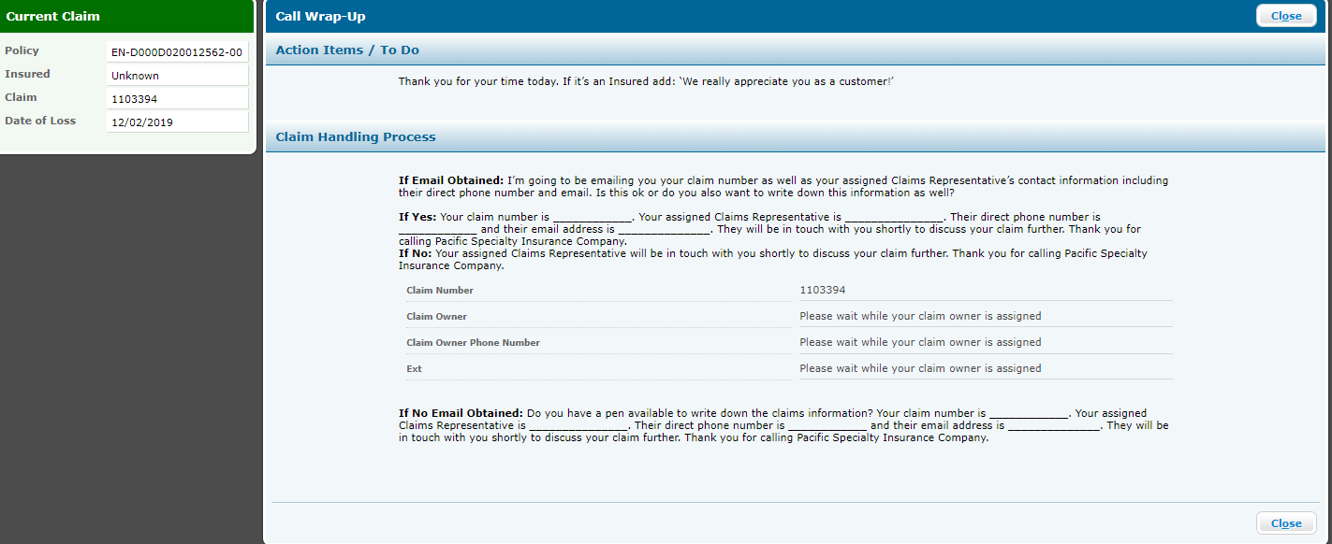

**Subject Of Insurance:**

Inside the Claim click on policy and select Subject of Insurance.

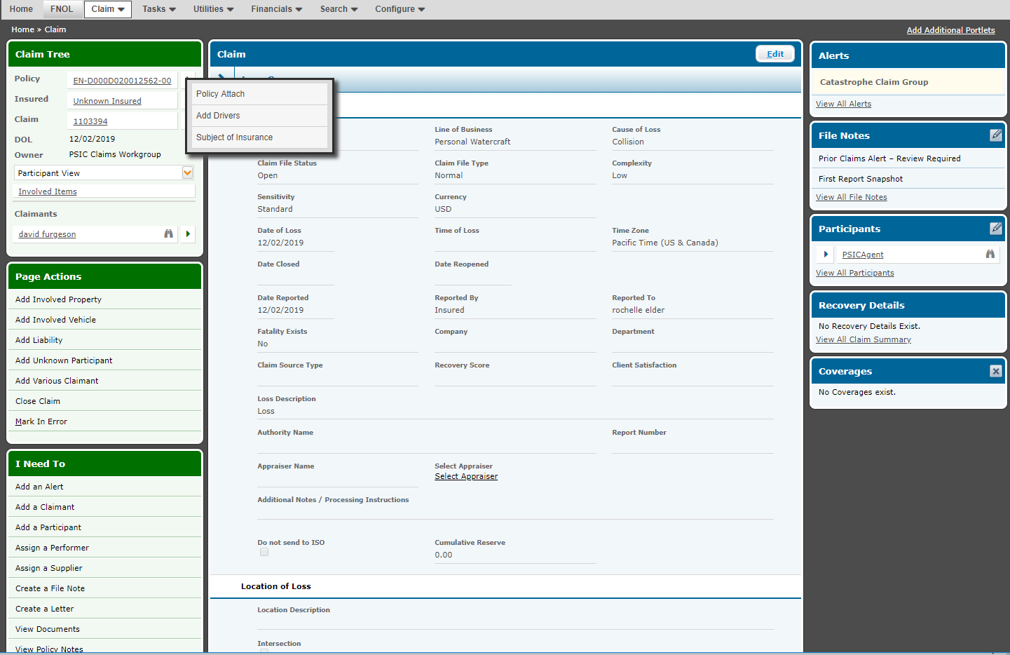

Subject of Insurance will down all the coverages applicable to the policy. We can only claims against the coverages mentioned under Subject of Insurance.

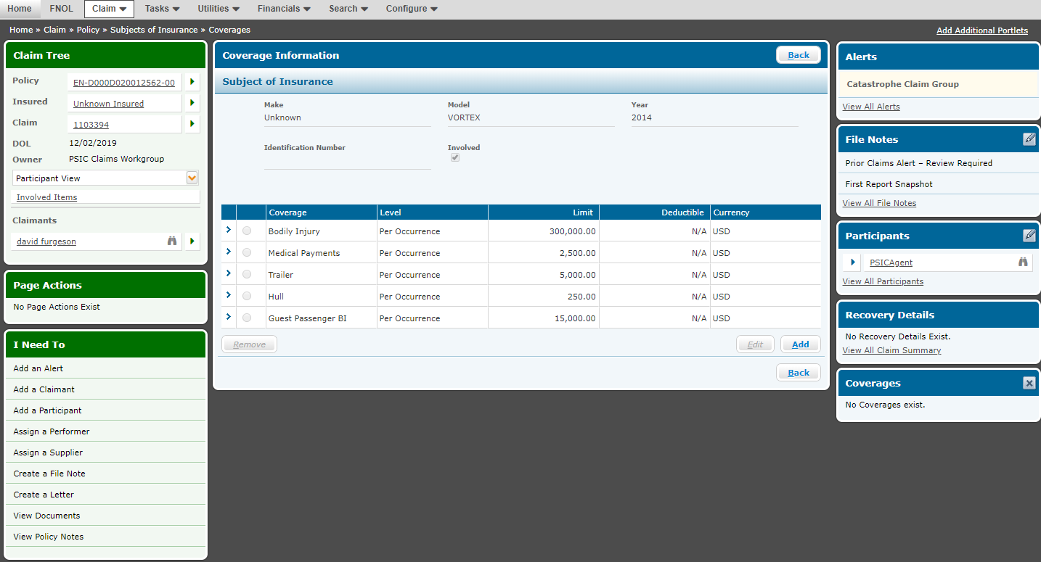

**Add Line:**

Select claimant and click on Add Line.

Line in Claims are mapped with Coverages from Policy. So in claims we can only claim against any coverage, and that is the reason in claims system coverages are treated as line.

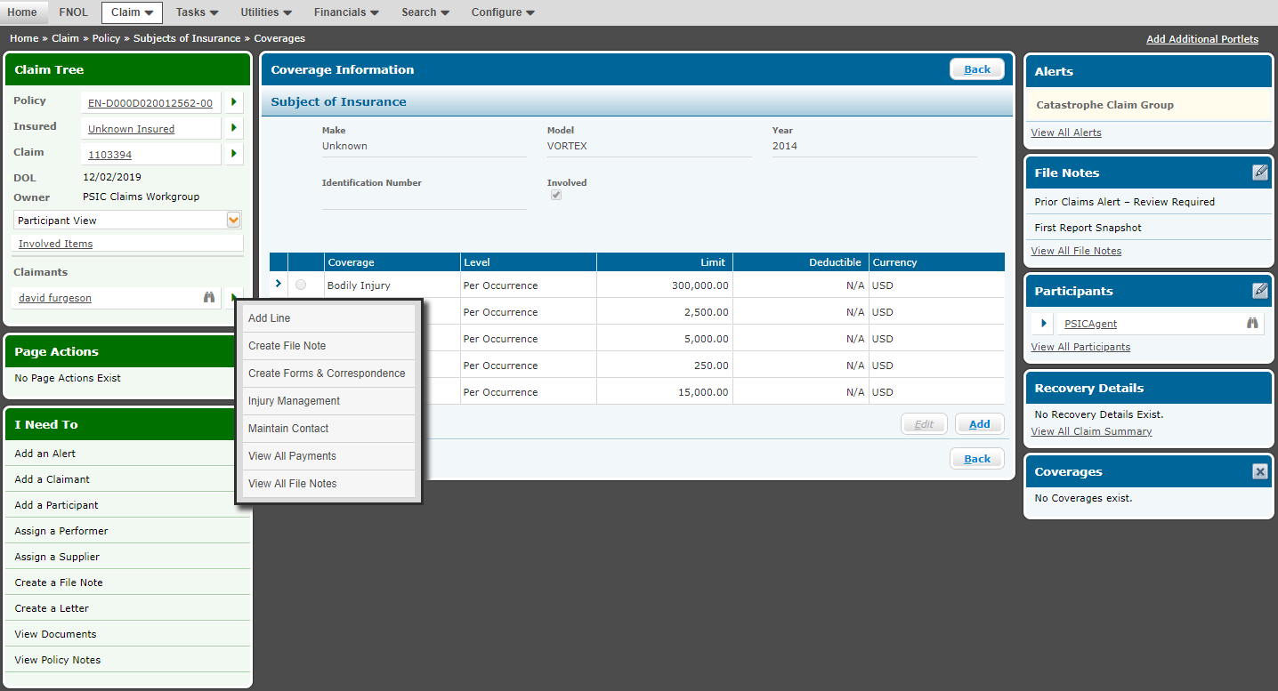

On Add Line screen we need to add the coverages from the available line section as line to the claims.

**Note:** The coverages we add as line should be present in the policy during policy creation.

Once the lines are added click on Save.

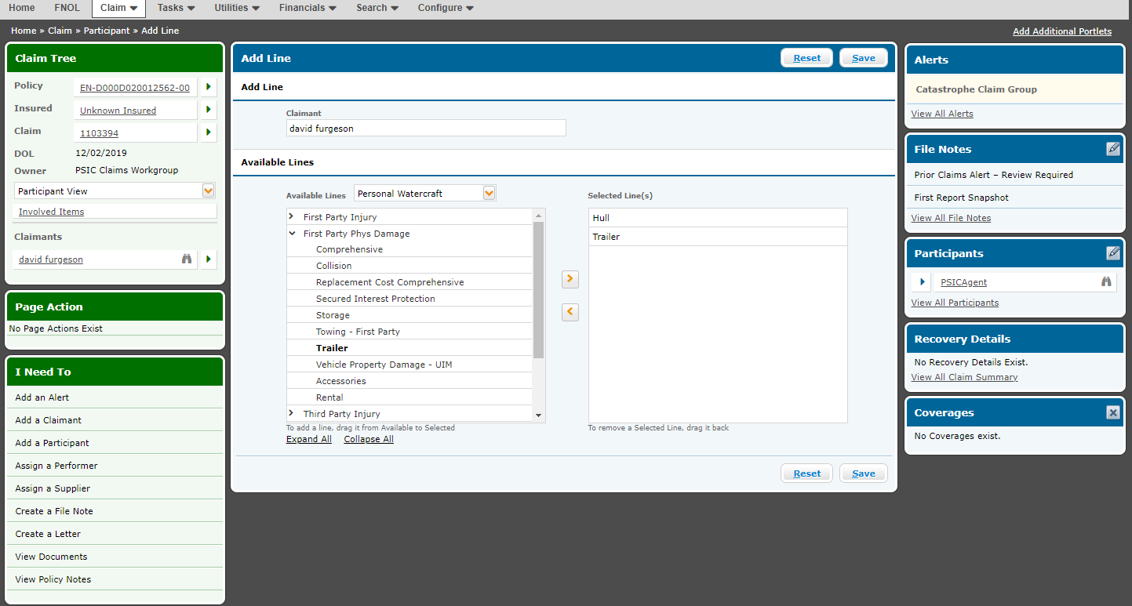

Once the lines are added they will display on Line screen just below the Claimant section

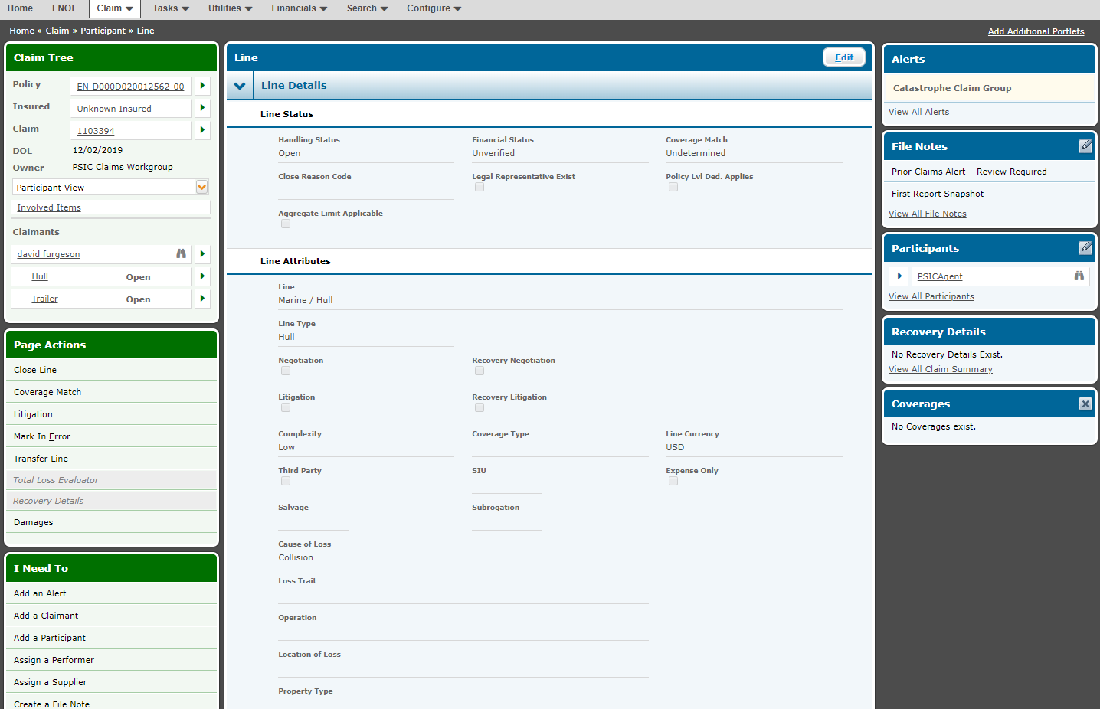

**Coverage Match:**

Once the line are added and displayed on Line screen we need to map the lines against the coverages to the policy. This will only pass when the lines that we added are also present as coverages to the policy or else it will show an error pop up message.

Once the coverage match is done system will display a confirmation message.

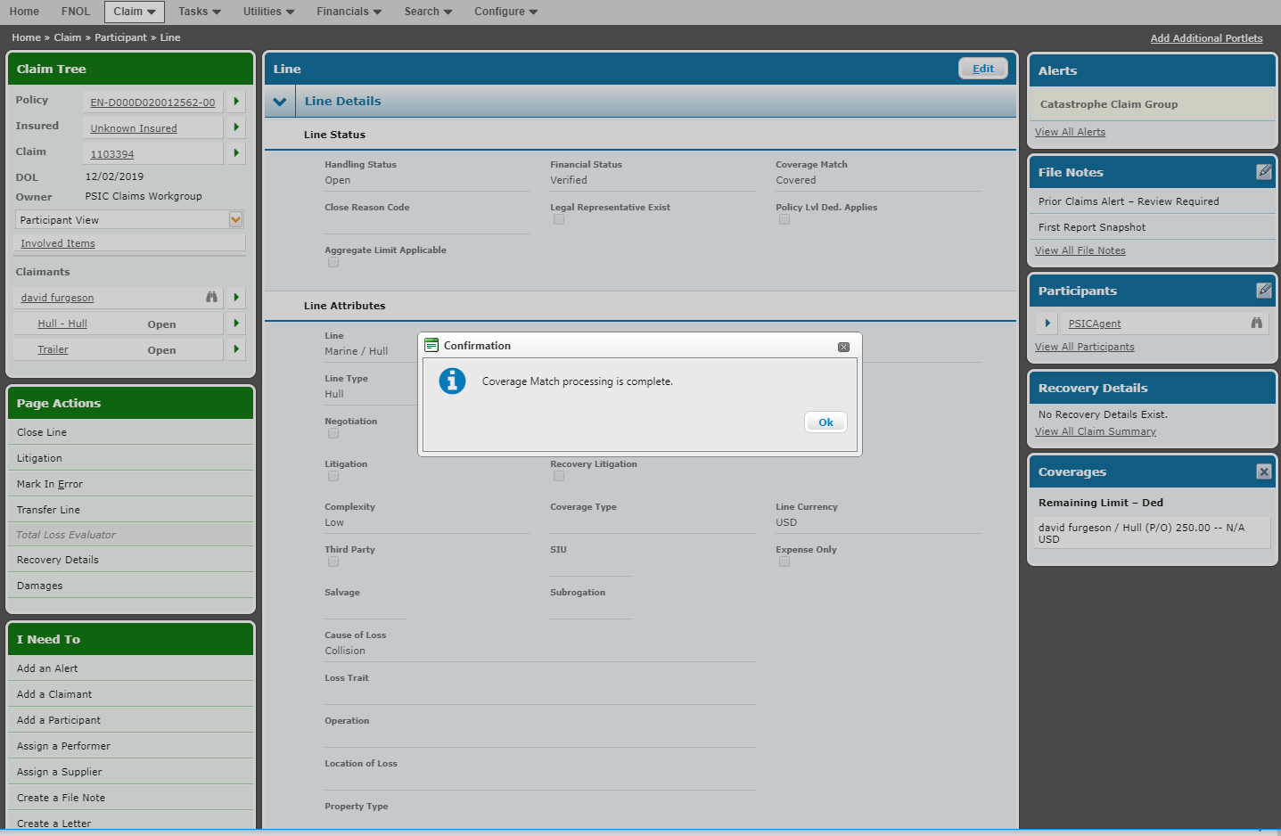

**Note:**

* The confirmation message will display as soon as any one of the coverage match is successful. Ex:
* We have added 4 Line on Add Line screen in claims.
* On Clicking on Coverage match only the 1st line is matched.
* The confirmation message will still be displayed and remaining 3 lines will be not matched.
* The lines which are matched with the coverages in policy will be displayed as Line (In Claims)- Coverages (In Policy). In the above example “Hull-Hull”. This means only the line Hull in claims is matched with the policy coverages.
* Make Payment to Claimant option will only be displayed for the coverages that are matched (In This ex only for Hull). Insurer will only pay (Make Payment) for the coverages which are matched.
* For rest all Lines which are not matched with the coverages from Policy no payment can be done.

**Make Payment To Claimant:**

By this option we can make payment to the Claimant on a particular line added to the claim.

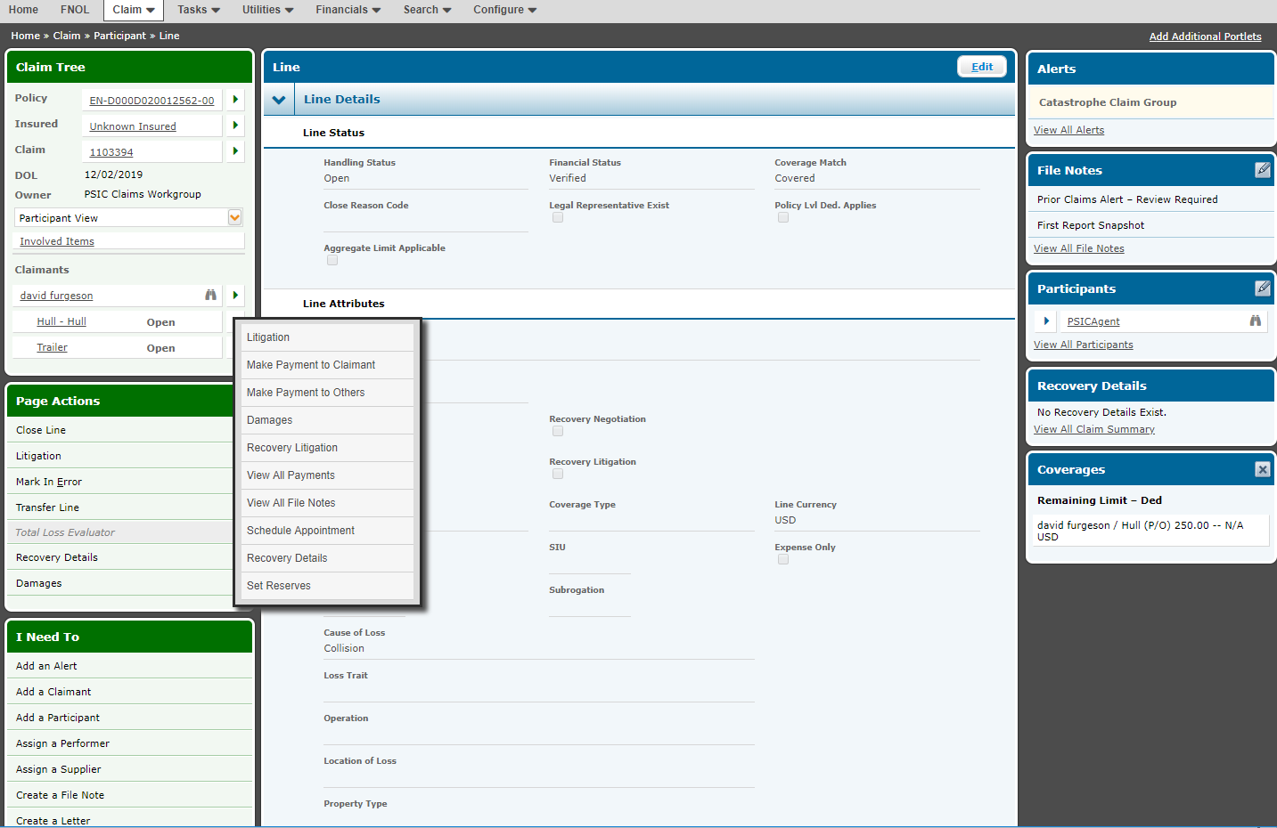

On Payee Information screen we need to fill the below mandatory details.

* Payee Name (This should match with Claimant name added during Claims creation)
* Invoice Number
* Invoice Amount
* Payment Type
* Service/Benefit
* Approval Amount
* Billed Amount

**Note:** The Invoice Amount, Approval Amount and Billed Amount cannot be more than the coverage limit. The reason is insurer is only liable to pay the claim against the coverage within the coverage limit.

Once all the details to filled click on Save.

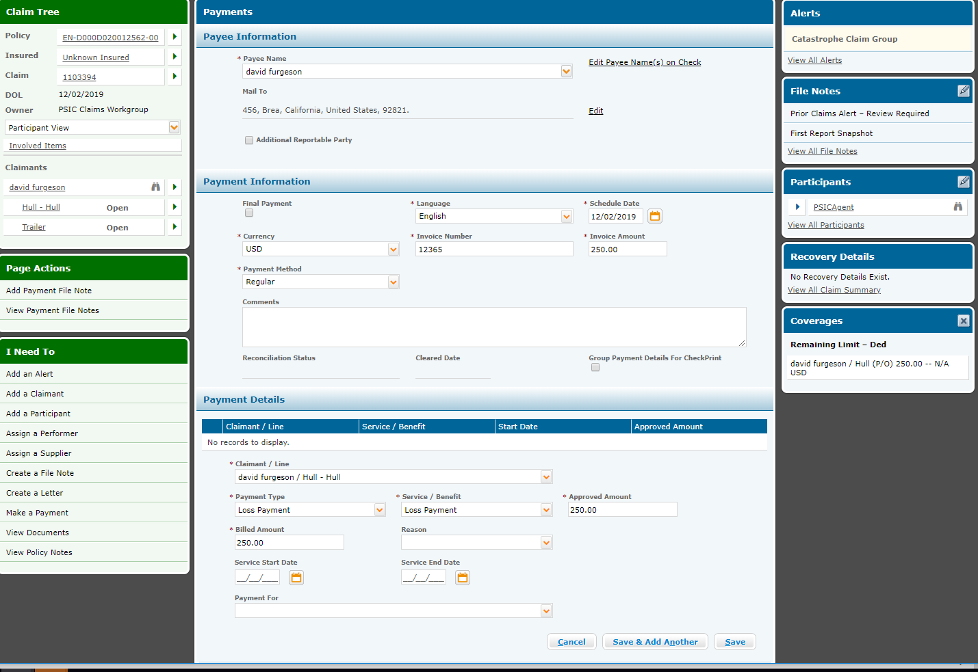Once the Payments details are saved it will be displayed under the Payment Details grid.

Click on Post.

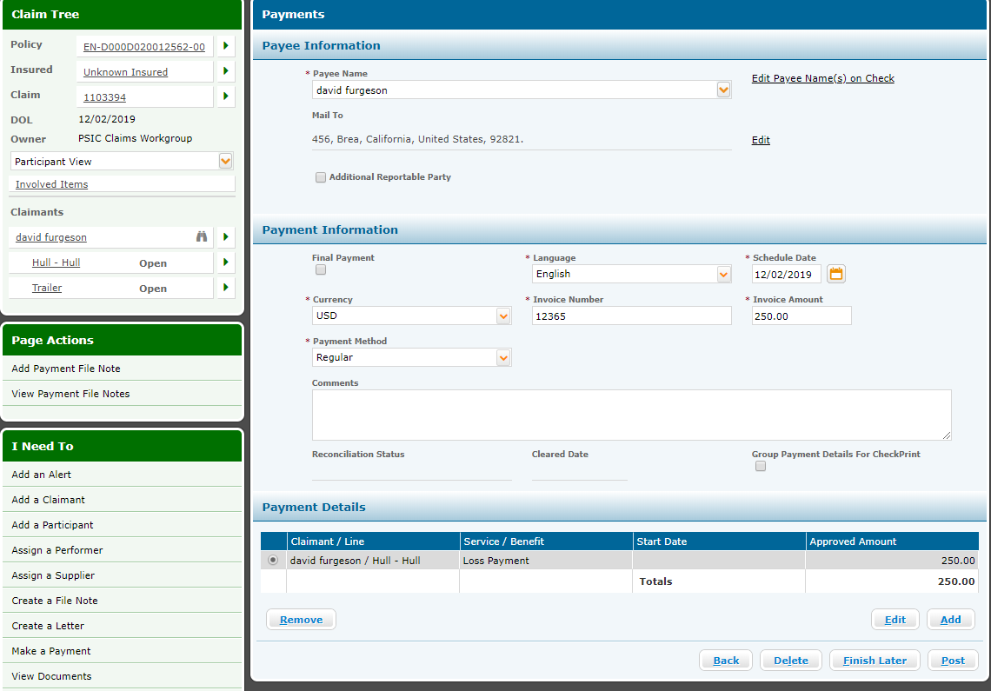

**Post Payment:**

Once the payment is posted it will be displayed on Financial Summery screen. The line against which the payment has been made will be displayed under Paid column.

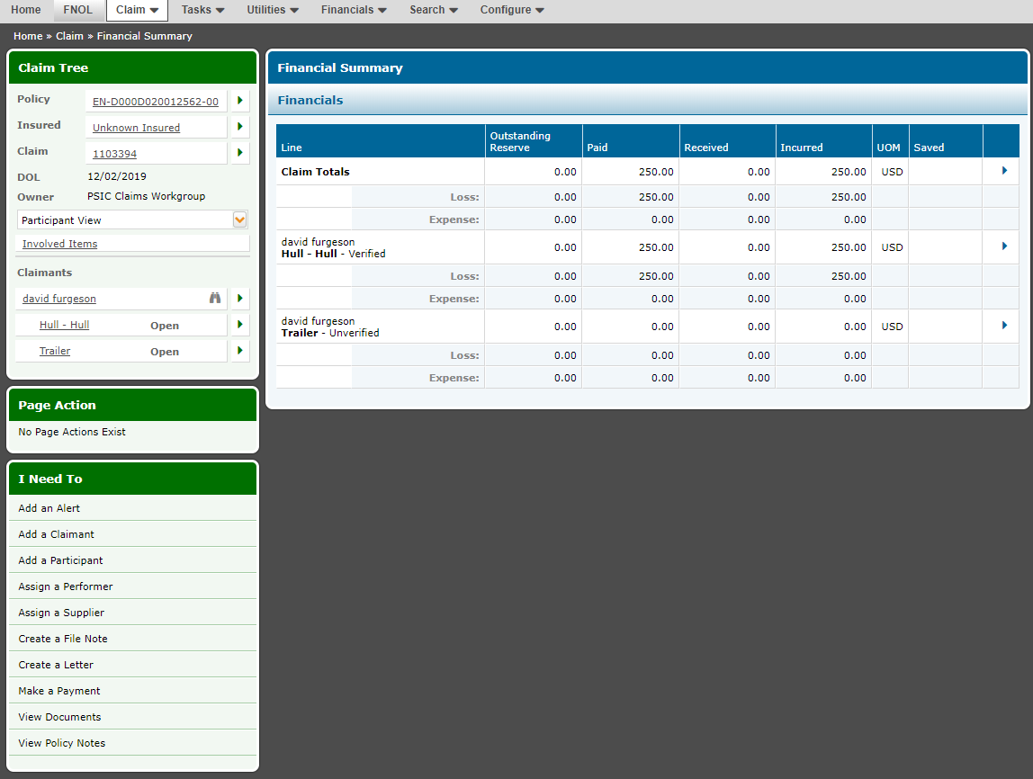

**Make Payment from Financial Summary page on Line level:**

We can also make payment to an existing claims from Financial Summary page

Steps: Search the claim and click on Claims> Financial> Financial Summary

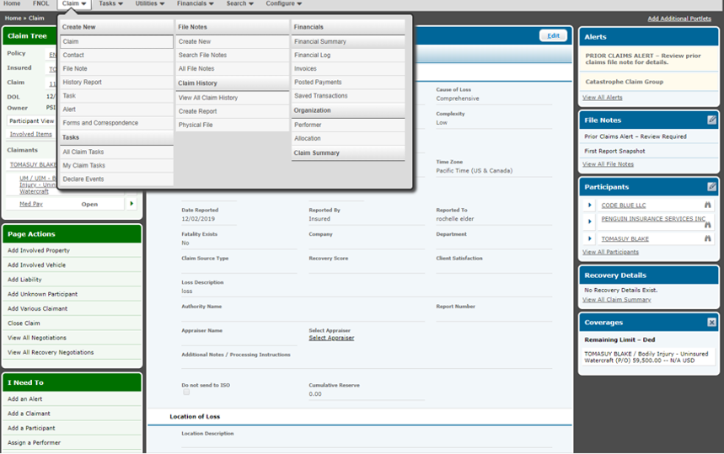

Select the line item against which we need to make the payment and click on Make Payment.

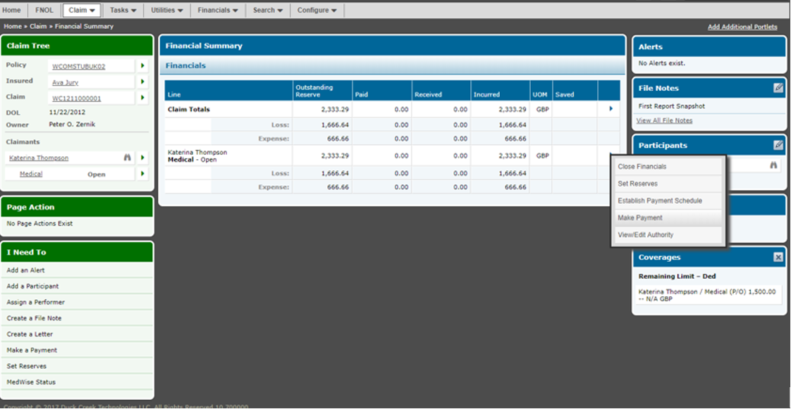

On Payee Information screen we need to fill the below mandatory details.

* Payee Name (This should match with Claimant name added during Claims creation)
* Invoice Number
* Invoice Amount
* Payment Type
* Service/Benefit
* Approval Amount
* Billed Amount

**Note:** The Invoice Amount, Approval Amount and Billed Amount cannot be more than the coverage limit. The reason is insurer is only liable to pay the claim against the coverage within the coverage limit.

Once all the details to filled click on Save.

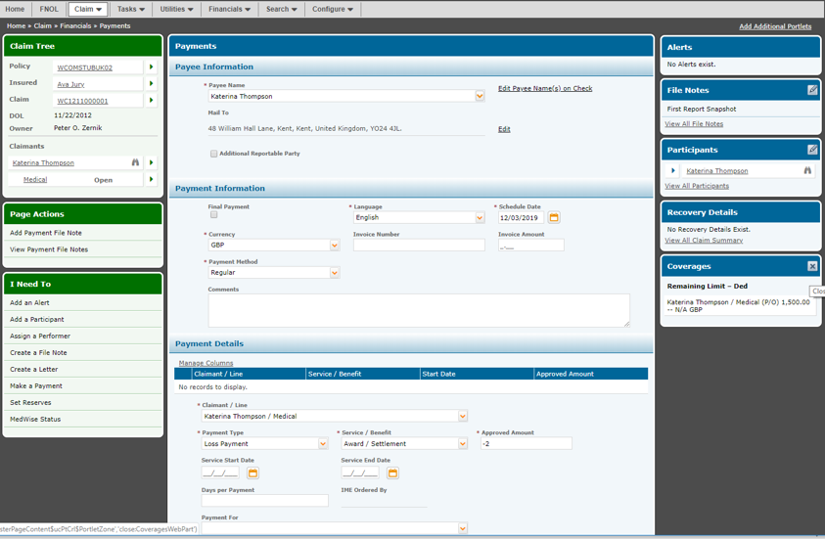

Once the Payments details are saved it will be displayed under the Payment Details grid.

Click on Post.

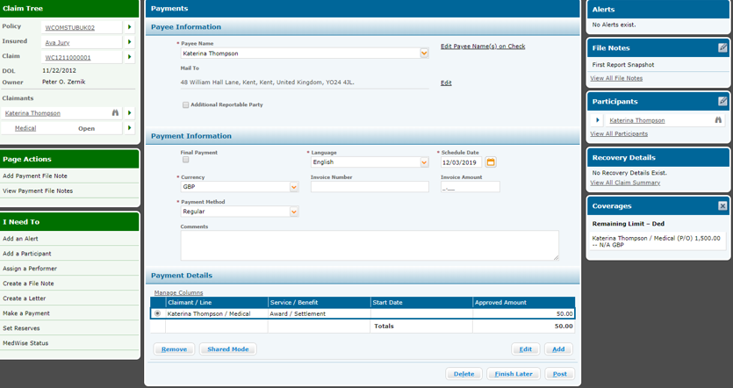

**Post Payment:**

Once the payment is posted it will be displayed on Financial Summery screen. The line against which the payment has been made will be displayed under Paid column.